Введение

Тема:

Цель:

Задачи:

Объект исследования:

Предмет исследования:

Гипотеза:

Методы исследования:

Методики исследования:

Актуальность:

Теоретическая часть

Полезные ресурсы:

<https://chem.nlm.nih.gov/chemidplus/unii/3G6A5W338E> Токсичность

<https://druginfo.nlm.nih.gov/drugportal/unii/3G6A5W338E>

<https://pubchem.ncbi.nlm.nih.gov/compound/2519>

<https://ncit.nci.nih.gov/ncitbrowser/ConceptReport.jsp?dictionary=NCI%20Thesaurus&code=C328>

<https://go.drugbank.com/drugs/DB00201> !!!

Структурная формула:

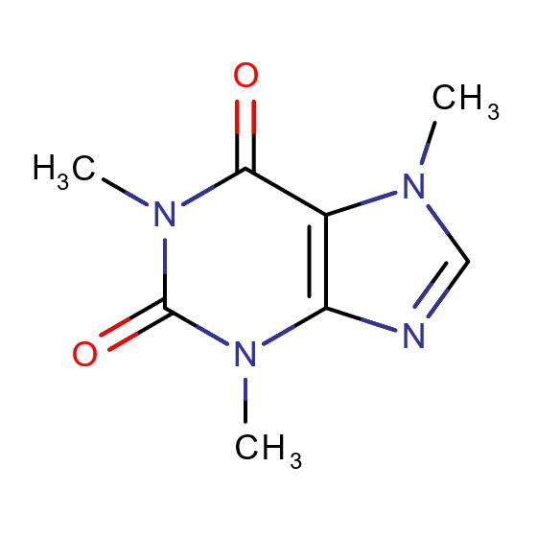

Фармакодинамика: Caffeine stimulates the central nervous system (CNS), heightening alertness, and sometimes causing restlessness and agitation. It relaxes smooth muscle, stimulates the contraction of cardiac muscle, and enhances athletic performance.[1](https://go.drugbank.com/drugs/DB00201#reference-A298),[12](https://go.drugbank.com/drugs/DB00201#reference-T716),[18](https://go.drugbank.com/drugs/DB00201#reference-L9857) Caffeine promotes gastric acid secretion and increases gastrointestinal motility. It is often combined in products with analgesics and ergot alkaloids, relieving the symptoms of migraine and other types of headaches. Finally, caffeine acts as a mild diuretic. Кофеин стимулирует центральную нервную систему, повышая бдительность, в некоторых случаях вызывает беспокойство и возбуждение. Он расслабляет гладкую мускулатуру, стимулирует сокращение сердечной мышцы и улучшает спортивные результаты. Кофеин способствует секреции желудочного сока и увеличивает моторику желудочно-кишечного тракта. Его часто сочетают в лекарственных средствах с анальгетиками и алкалоидами спорыньи, что позволяет снять симптомы мигрени и других типов головных болей. Также кофеин действует как мягкое мочегонное средство.

Токсичность: The oral LD50 of caffeine in rats is 192 mg/kg. An acute fatal overdose of caffeine in humans is about 10–14 grams (equivalent to 150–200 mg/kg of body weight). При пероральном приёме LD50 кофеина для крыс составляет 192 мг/кг. Летальная дозировка для человека составляет около 10 -14 г (эквивалентно 150 – 200 мг/кг) Больше информации по ссылкам

Механизм действия: The mechanism of action of caffeine is complex, as it impacts several body systems, which are listed below. The effects as they relate to various body systems are described as follows:

* **General and cellular actions.** Caffeine exerts several actions on cells, but the clinical relevance is poorly understood. One probable mechanism is the inhibition of nucleotide phosphodiesterase enzymes, adenosine receptors, regulation of calcium handling in cells, and participates in adenosine receptor antagonism. Phosphodiesterase enzymes regulate cell function via actions on second messengers cAMP and cGMP. This causes lipolysis through activation of hormone-sensitive lipases, releasing fatty acids and glycerol.
* **Respiratory.** The exact mechanism of action of caffeine in treating apnea related to prematurity is unknown, however, there are several proposed mechanisms, including respiratory center stimulation in the central nervous system, a reduced threshold to hypercapnia with increased response, and increased consumption of oxygen, among others.[16](https://go.drugbank.com/drugs/DB00201#reference-L9851) The blocking of the adenosine receptors enhances respiratory drive via an increase in brain medullary response to carbon dioxide, stimulating ventilation and respiratory drive, while increasing contractility of the diaphragm.
* **Central nervous system.** Caffeine demonstrates antagonism of all 4 adenosine receptor subtypes (A1, A2a, A2b, A3) in the central nervous system. Caffeine's effects on alertness and combatting drowsiness are specifically related to the antagonism of the A2a receptor.
* **Renal system.** Caffeine has diuretic effects due to is stimulatory effects on renal blood flow, increase in glomerular filtration, and increase in sodium excretion.
* **Cardiovascular system.** Adenosine receptor antagonism at the A1 receptor by caffeine stimulates inotropic effects in the heart. Blocking of adenosine receptors promotes catecholamine release, leading to stimulatory effects occurring in the heart and the rest of the body. In the blood vessels, caffeine exerts direct antagonism of adenosine receptors, causing vasodilation. It stimulates the endothelial cells in the blood vessel wall to release nitric oxide, potentiating blood vessel relaxation. Catecholamine release, however, antagonizes this and exerts inotropic and chronotropic effects on the heart, ultimately leading to vasoconstriction. Finally, caffeine is shown to raise systolic blood pressure measurements by 5 to 10 mmHg when it is not taken regularly, versus no effect in those who consume it regularly. The vasoconstricting effects of caffeine are beneficial in migraines and other types of headache, which are normally caused by vasodilation in the brain. Нужно перевести.

Передозировка кофеином: In the case of caffeine overdose, seizures may occur, as caffeine is a central nervous system stimulant. It should be used with extreme caution in those with epilepsy or other seizure disorders. Symptoms of overdose may include nausea, vomiting, diarrhea, and gastrointestinal upset, agitation, anxiety, restlessness, insomnia, tachycardia, tremors, tachycardia, psychomotor agitation, and, in some cases, death can occur, depending on the amount of caffeine consumed. В случае передозировки кофеином могут возникать судороги, так как кофеин является стимулятором центральной нервной системы. Его следует ghbvtyznm с особой осторожностью при эпилепсии или других судорожных расстройствах. Симптомы передозировки могут включать тошноту, рвоту, диарею, желудочно-кишечные расстройства, беспокойство, бессонницу, тахикардию, тремор, психомоторное возбуждение и, в некоторых случаях, смерть, в зависимости от количества потребленного кофеина.

Практическая часть